JUNIT ASSERTIONS

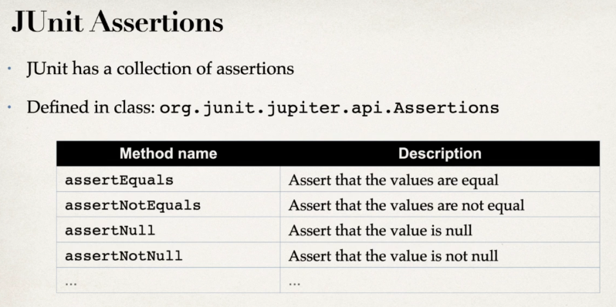

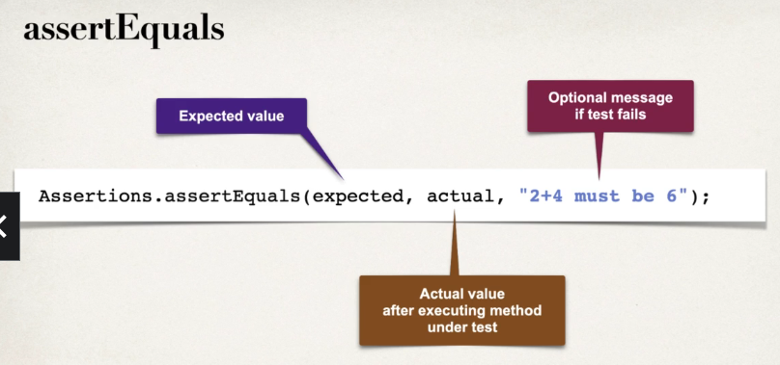

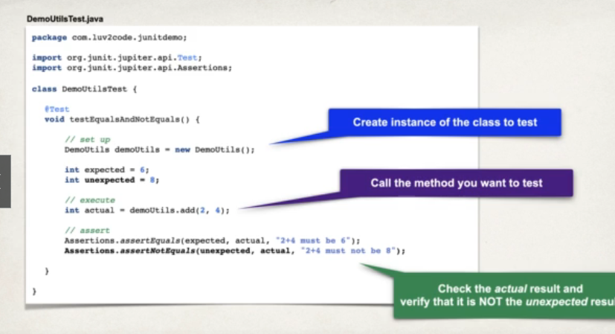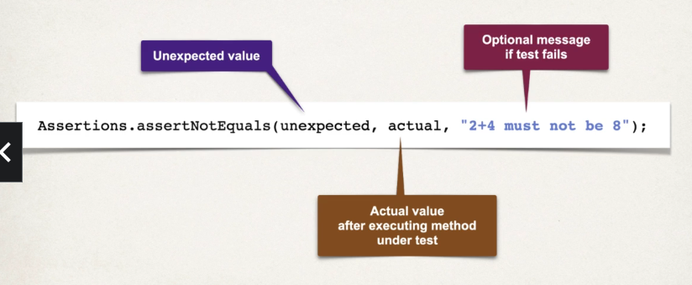

STATIC IMPORT

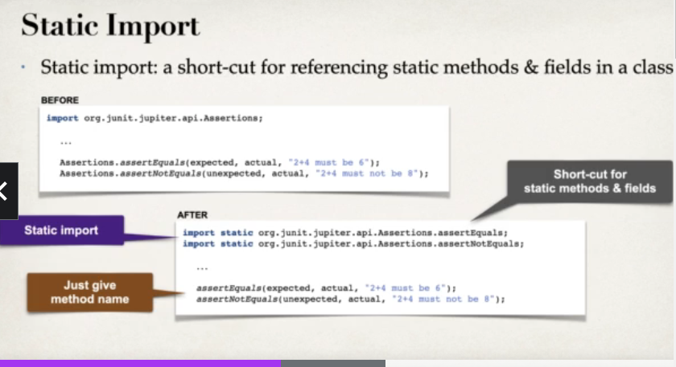

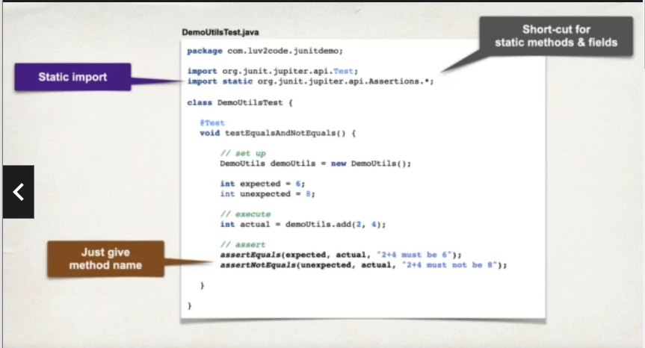

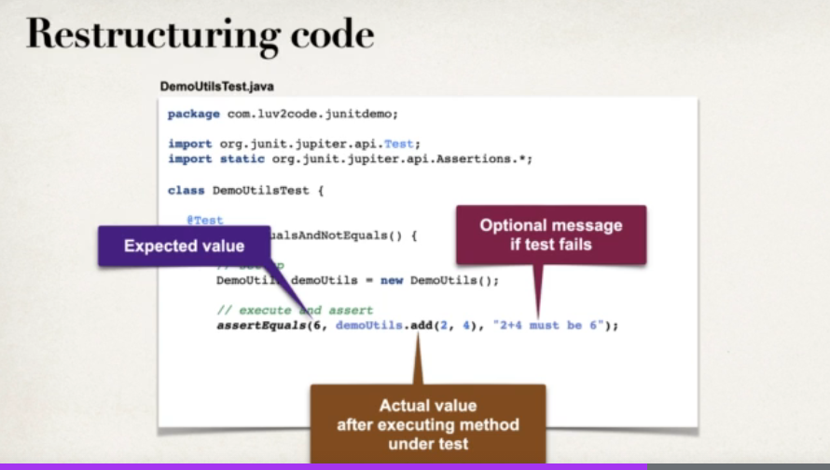

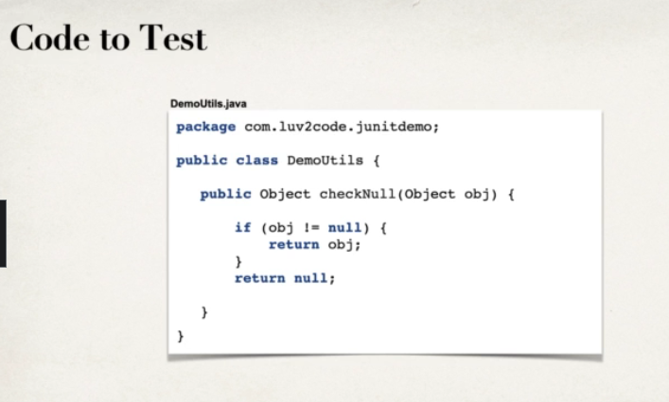

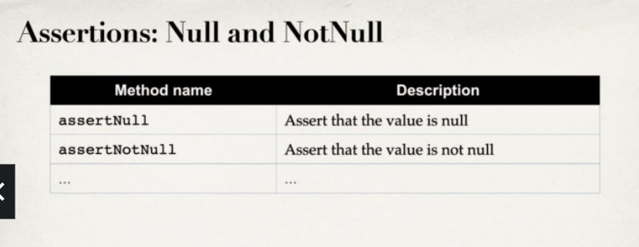

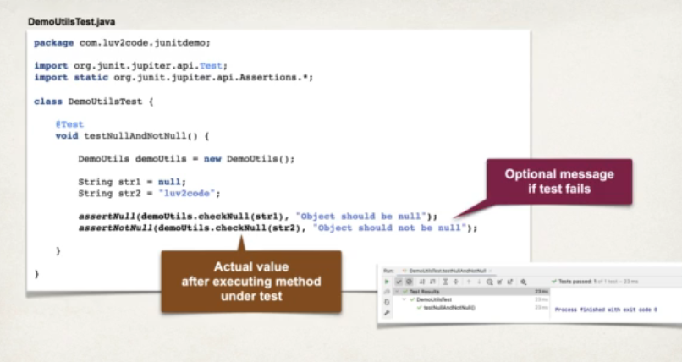

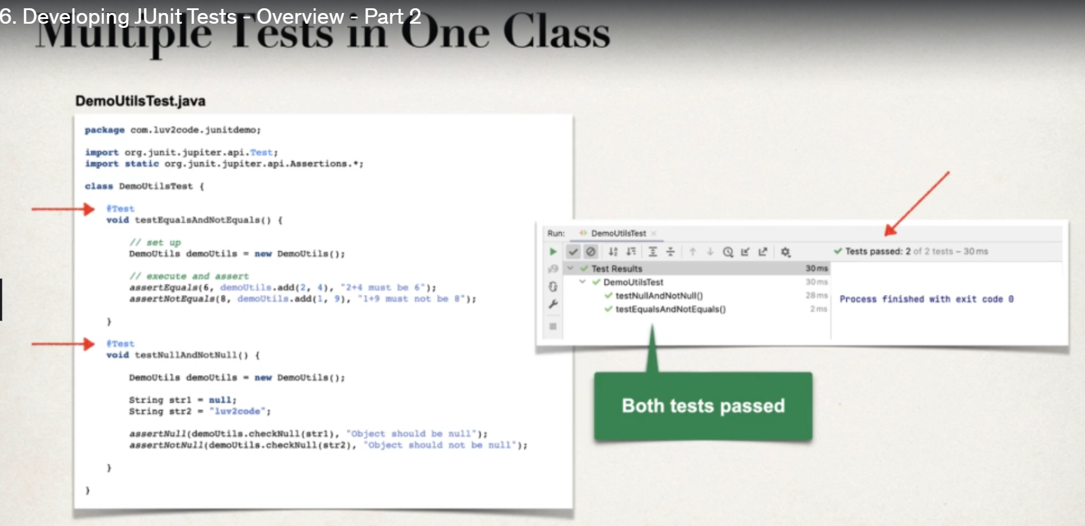

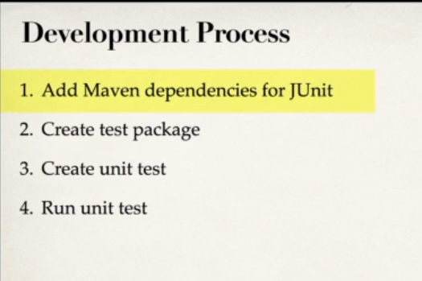

Now we will write the below class

|  |
| --- |
| **package** com.chadderby.unittest.UnitTestingPractise;  **public** **class** DemoUtils {    **public** **int** add(**int** a,**int** b) {  **return** a+b;  }    **public** Object checkNull(Object obj) {  **if**(obj!=**null**) {  **return** obj;  }  **return** **null**;  }  } |
|  |

For the above classwe will write the test cases

|  |
| --- |
| **package** com.chadderby.unittest.UnitTestingPractise;  **import** **static** org.junit.jupiter.api.Assertions.*assertEquals*;  **import** **static** org.junit.jupiter.api.Assertions.*assertNotEquals*;  **import** **static** org.junit.jupiter.api.Assertions.*assertNotNull*;  **import** **static** org.junit.jupiter.api.Assertions.*assertNull*;  **import** org.junit.jupiter.api.Test;  **public** **class** DemoUtilsTest {  @Test  **void** testEqualsAndNotEquals() {    DemoUtils demoUtils=**new** DemoUtils();  *assertEquals*(4,demoUtils.add(2,2),"2+4 must be 6");  *assertNotEquals*(11,demoUtils.add(1,9),"1+9 must not be 6");      }    @Test  **void** testNullAndNotNull() {  DemoUtils demoUtils=**new** DemoUtils();  String str1=**null**;  String str2="luv2code";  *assertNull*(demoUtils.checkNull(str2),"Object should be null");  *assertNotNull*(demoUtils.checkNull(str2),"Object should not be null");      }  } |

LIFECYCLE METHODS

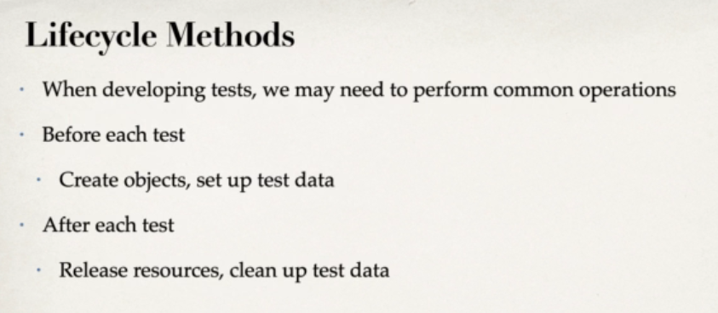

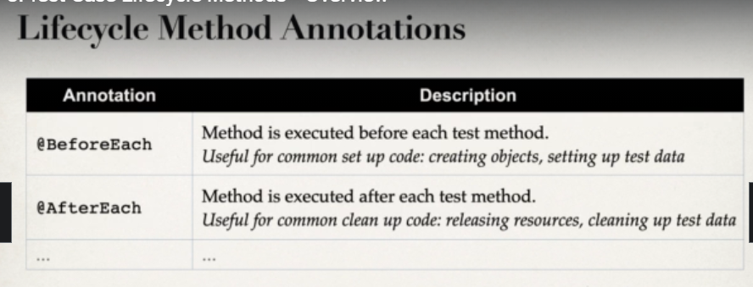

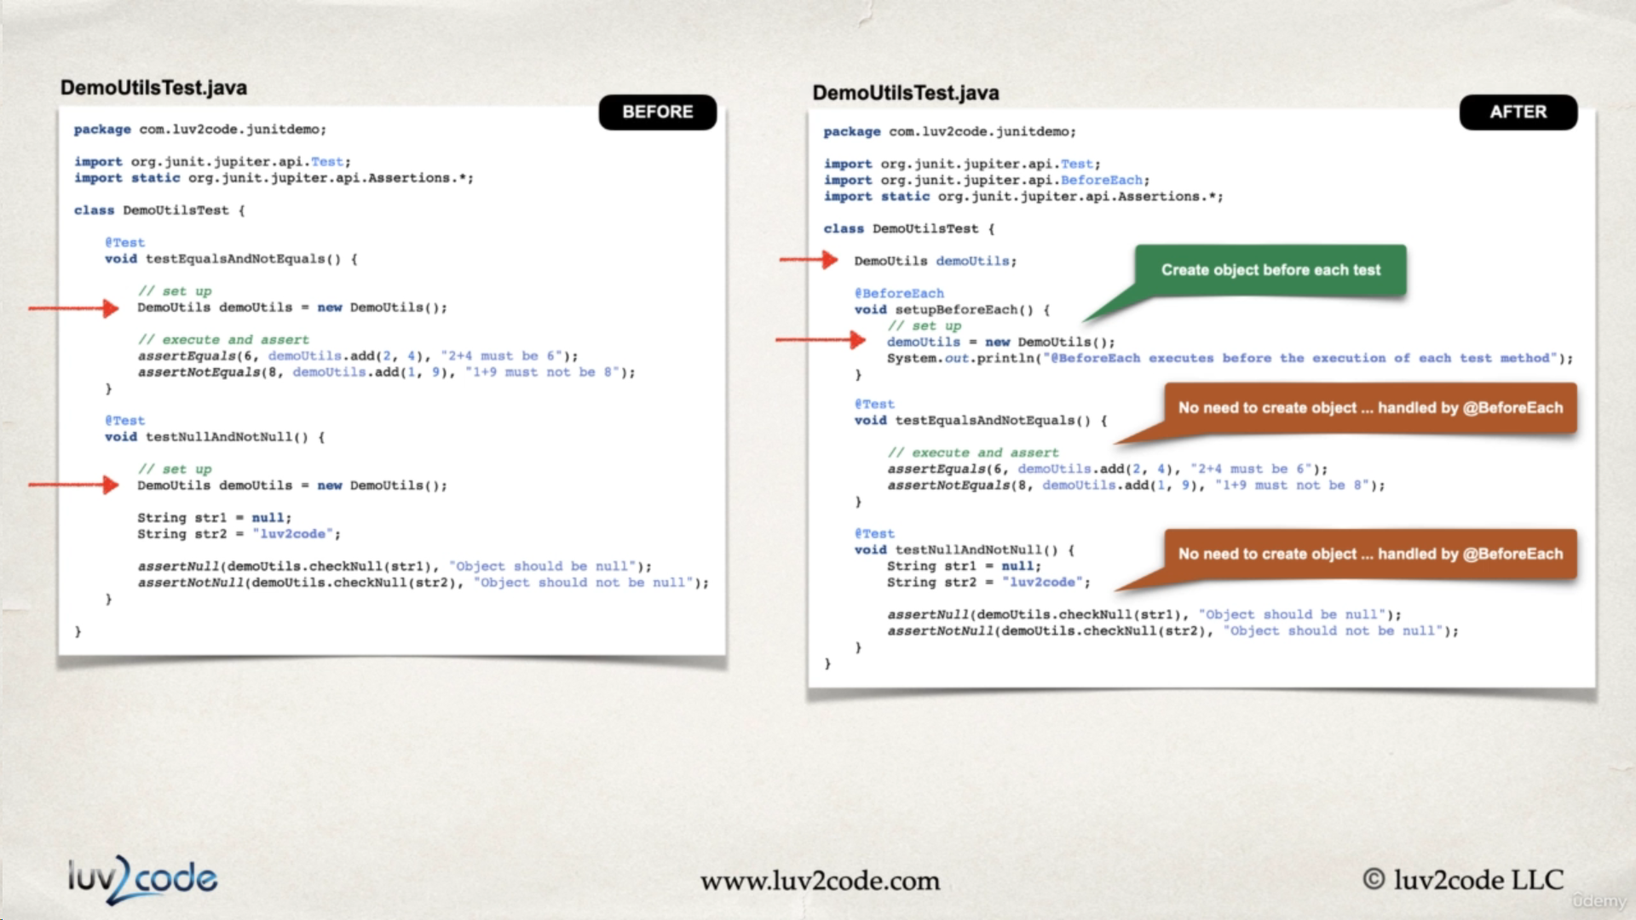

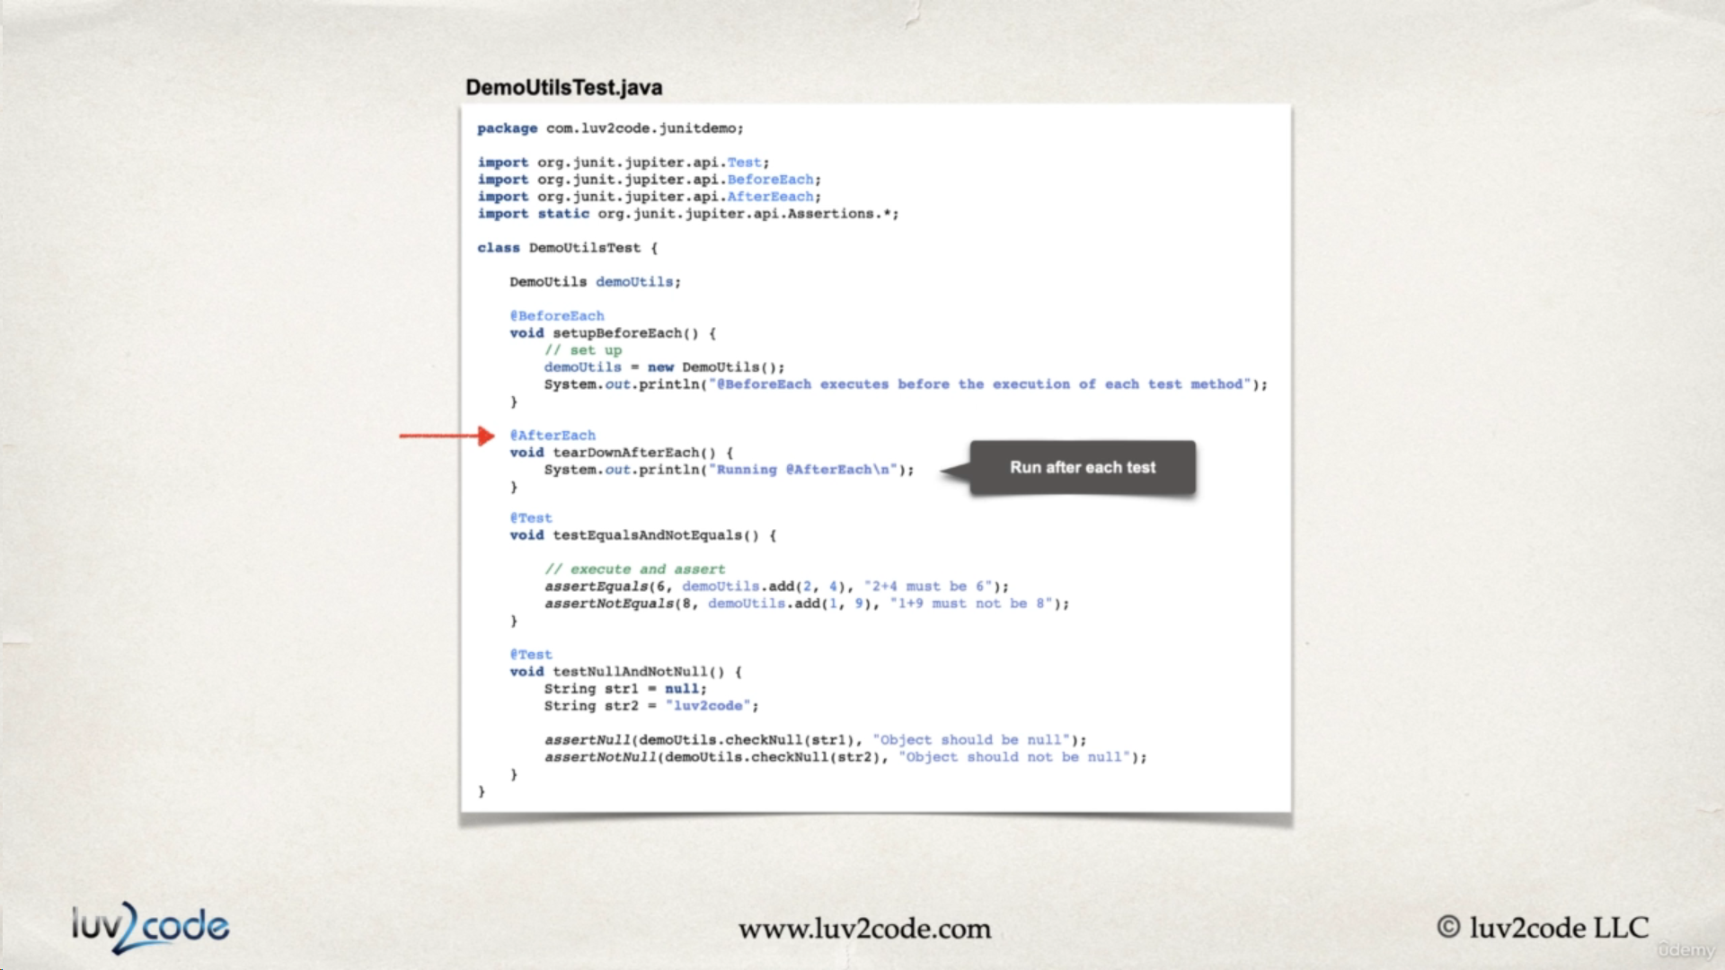

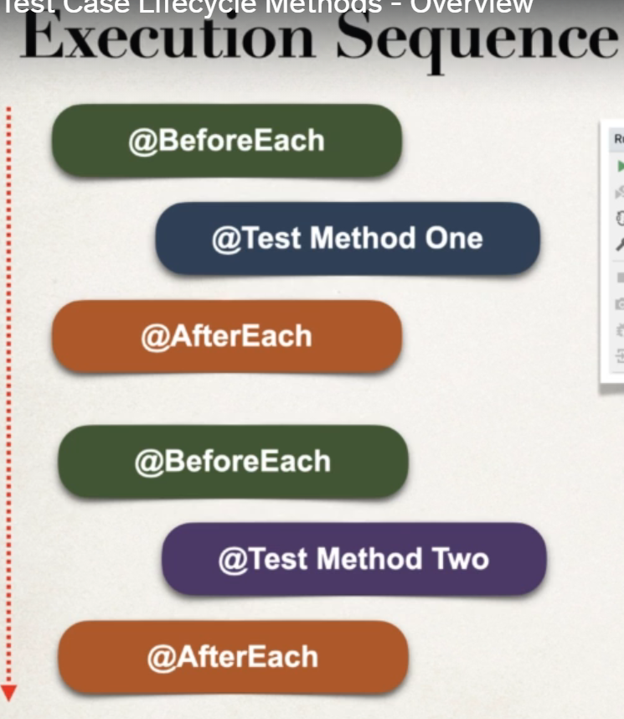

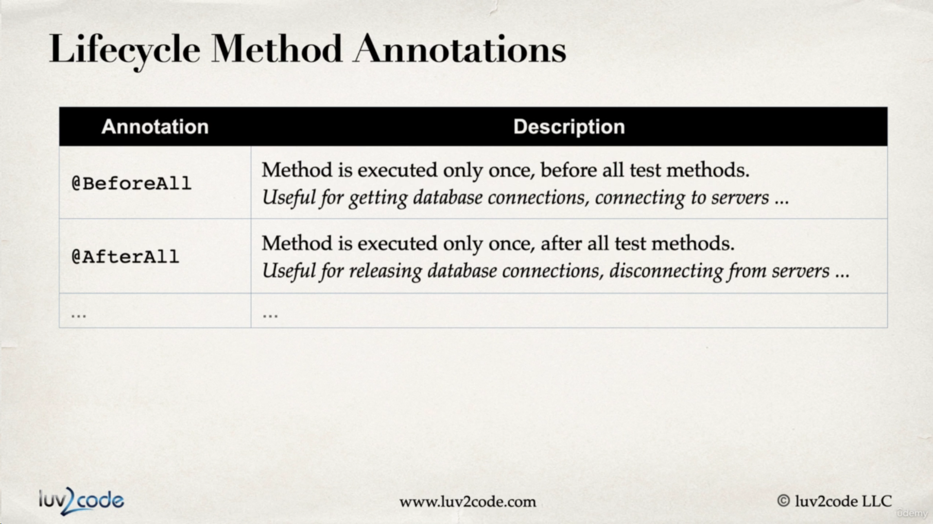

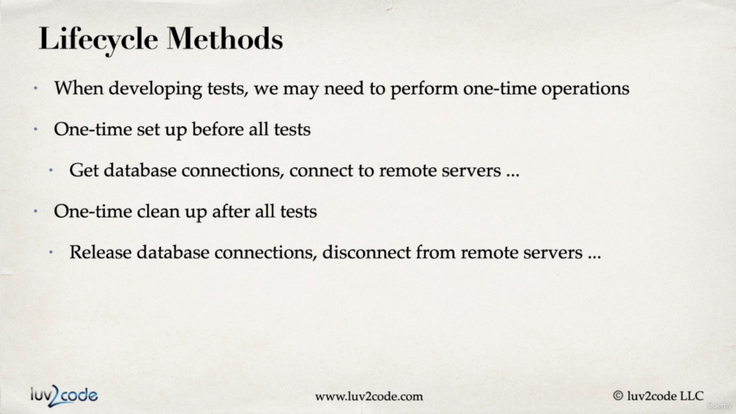  
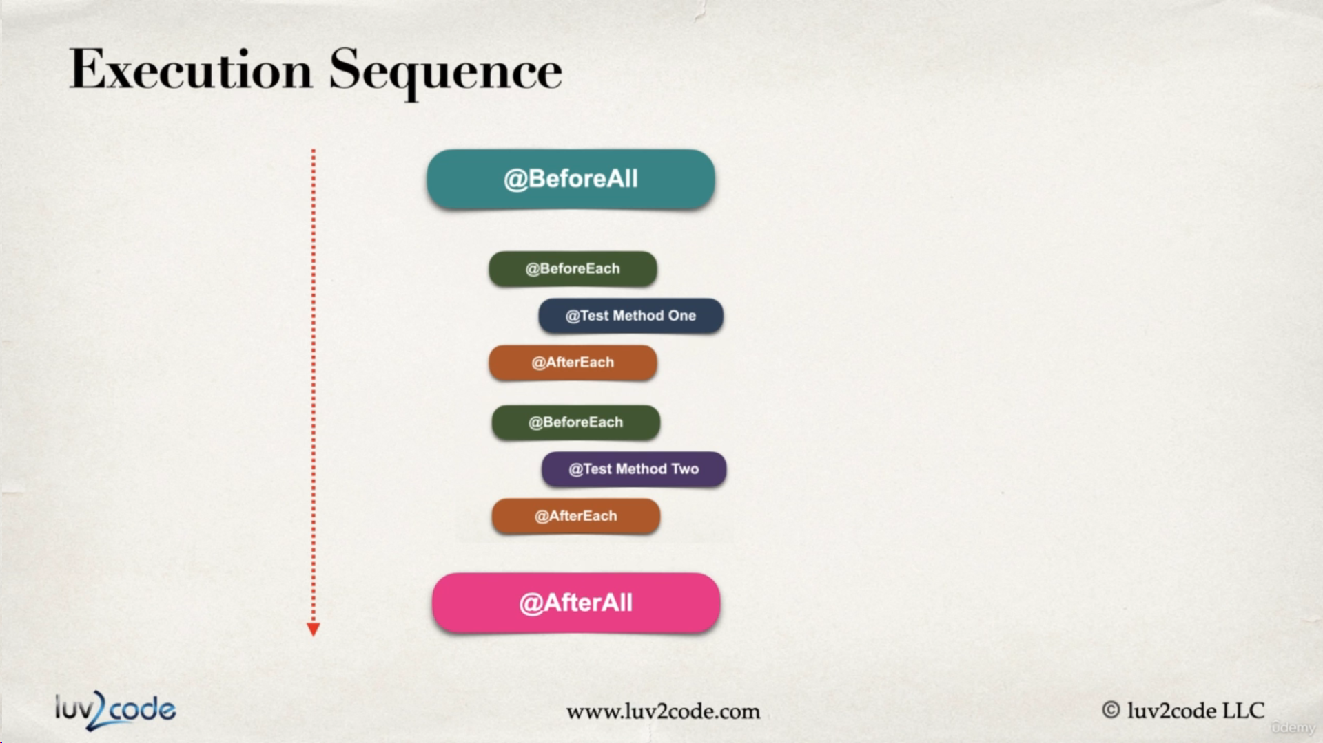

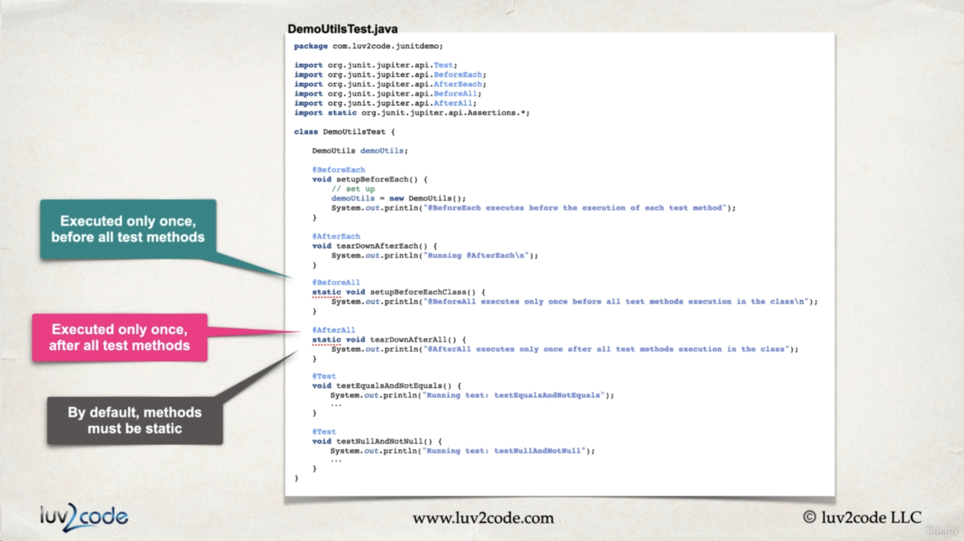

Code for lifecycle methods

|  |
| --- |
| **package** com.chadderby.unittest.UnitTestingPractise;  **import** **static** org.junit.jupiter.api.Assertions.*assertEquals*;  **import** **static** org.junit.jupiter.api.Assertions.*assertNotEquals*;  **import** **static** org.junit.jupiter.api.Assertions.*assertNotNull*;  **import** **static** org.junit.jupiter.api.Assertions.*assertNull*;  **import** org.junit.jupiter.api.AfterAll;  **import** org.junit.jupiter.api.AfterEach;  **import** org.junit.jupiter.api.BeforeAll;  **import** org.junit.jupiter.api.BeforeEach;  **import** org.junit.jupiter.api.Test;  **public** **class** DemoUtilsTest {    DemoUtils demoUtils;    @BeforeEach  **void** setupBeforeEach() {  demoUtils=**new** DemoUtils();  System.***out***.println("Before each executes before the execution of each test case");  }    @AfterEach  **void** tearDownAfterEach() {  System.***out***.println("Running after each test case");  }    @BeforeAll  **static** **void** setupBeforeEachClass() {  System.***out***.println("before all exceutes before all test methods executes"); }    @AfterAll  **static** **void** setupAfterEachClass() {  System.***out***.println("After all executes after all test methods are executed");  }  @Test  **void** testEqualsAndNotEquals() {  System.***out***.println("Running test:testEqualsAndNotEquals");  *assertEquals*(4,demoUtils.add(2,2),"2+4 must be 6");  *assertNotEquals*(11,demoUtils.add(1,9),"1+9 must not be 6");      }    @Test  **void** testNullAndNotNull() {  System.***out***.println("Running test: objectnullornot");  String str1=**null**;  String str2="luv2code";  *assertNull*(demoUtils.checkNull(str1),"Object should be null");  *assertNotNull*(demoUtils.checkNull(str2),"Object should not be null");      }  } |

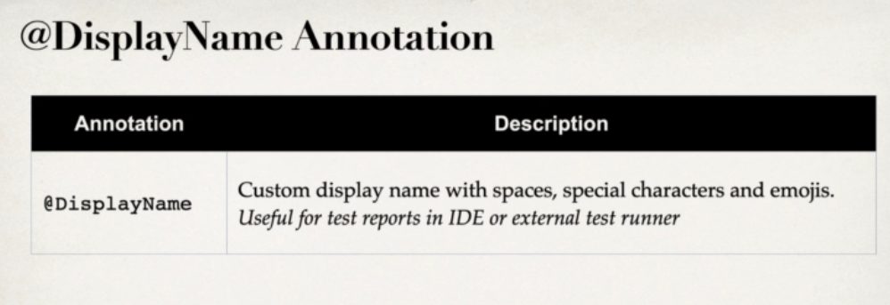

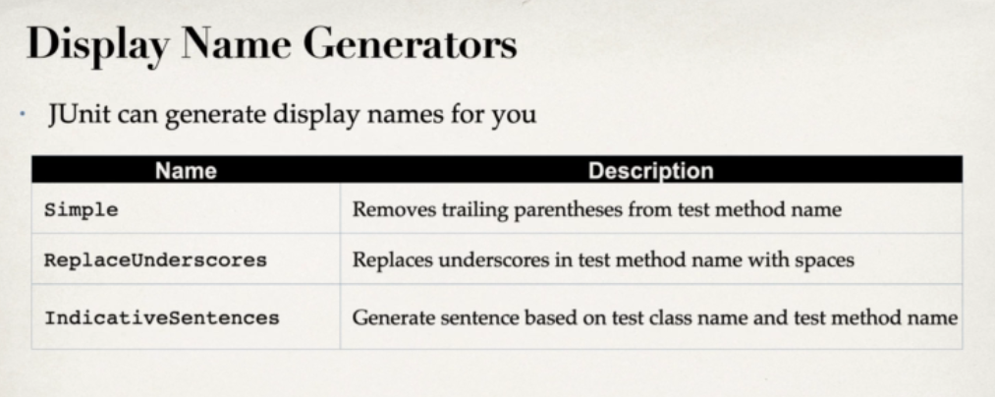

|  |
| --- |
| @DisplayNameGeneration(DisplayNameGenerator.ReplaceUnderscores.**class**)  **public** **class** DemoUtilsTest {    DemoUtils demoUtils;    @BeforeEach  **void** setupBeforeEach() {  demoUtils=**new** DemoUtils();  System.***out***.println("Before each executes before the execution of each test case");  }    @AfterEach  **void** tearDownAfterEach() {  System.***out***.println("Running after each test case");  }    @BeforeAll  **static** **void** setupBeforeEachClass() {  System.***out***.println("before all exceutes before all test methods executes"); }    @AfterAll  **static** **void** setupAfterEachClass() {  System.***out***.println("After all executes after all test methods are executed");  }  @Test  //@DisplayName("Equals and Not Equals")  **void** test_Equals_AndNotEquals() {  System.***out***.println("Running test:testEqualsAndNotEquals");  *assertEquals*(4,demoUtils.add(2,2),"2+4 must be 6");  *assertNotEquals*(11,demoUtils.add(1,9),"1+9 must not be 6");      }    @Test  //@DisplayName("Null and Not Null")  **void** testNullAndNotNull() {  System.***out***.println("Running test: objectnullornot");  String str1=**null**;  String str2="luv2code";  *assertNull*(demoUtils.checkNull(str1),"Object should be null");  *assertNotNull*(demoUtils.checkNull(str2),"Object should not be null");      }  } |

Giving our unit tests a specific name so that they run with that name only.

SAME AND NOT SAME

